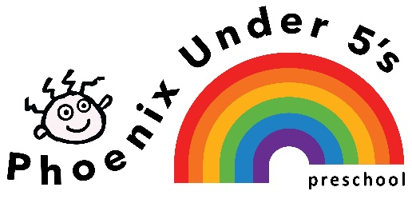

Nut Free Policy
We aim to make Phoenix under 5’s Pre School a Nut free Pre-school. This will mean no food products containing nuts are to be brought into the building.
We hope this will reduce the risk of any child, who may have or develop an allergy to nuts coming into contact with a food product which could potentially be very harmful to them.
We realise that many foods are labelled as having ‘traces of nut’ or ‘cannot guarantee nut free’ which are very difficult to avoid. We will speak to parents of any children who join the setting who have a nut allergy to establish the severity of the allergy and put in place a risk assessment.
In order to reduce the risk of an allergic reaction for child in our care:
The Nursery will:
- Make sure cooking ingredients do not include nuts
- Inform all new parents of this policy
- Place a copy of the policy in the Policy Folder which is kept in the Parents’ room
- Include this information in the welcome pack
- Remind families periodically in Newsletters
- Staff will not bring food containing nuts into the nursery
We ask parents:
- When preparing packed lunches please do not include any food containing nuts (e.g. cereal bars, peanut butter, Nutella)
- If bringing a cake/biscuits/cookies into the nursery to celebrate your child’s birthday please ensure the list of ingredients do not include nuts.
- If giving a present to members of staff, please do not include nuts.

Policy adopted: January 2019
Review date: January 2020
Signed on behalf: Phoenix under 5’s Pre School: Jasmin Walker
Position: Manager

